|  |  |  |
| --- | --- | --- |
|  | **Rochester Institute of Technology**  **Golisano College of Computing and Information Sciences**  **School of Interactive Games and Media**  **2145 Golisano Hall – (585) 475-7680** |  |

**Data Structures & Algorithms for Games & Simulation II**

**IGME 309**

**Bounding Space**

This exercise follows lecture D11

1. Under _Binary look for the example solution. It will look like this:

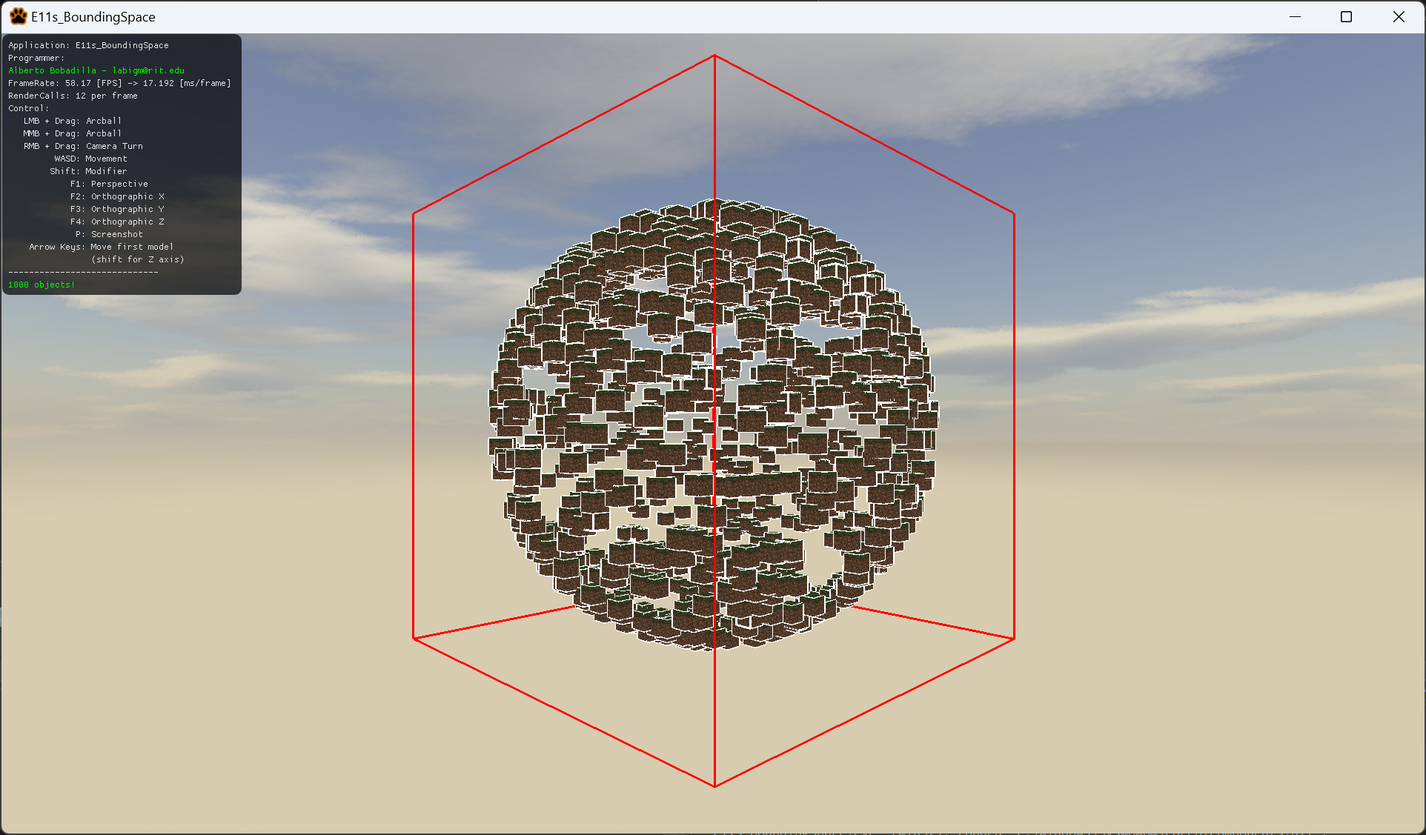

1. Out of the box some values are added for v3Center and v3Size to show something like this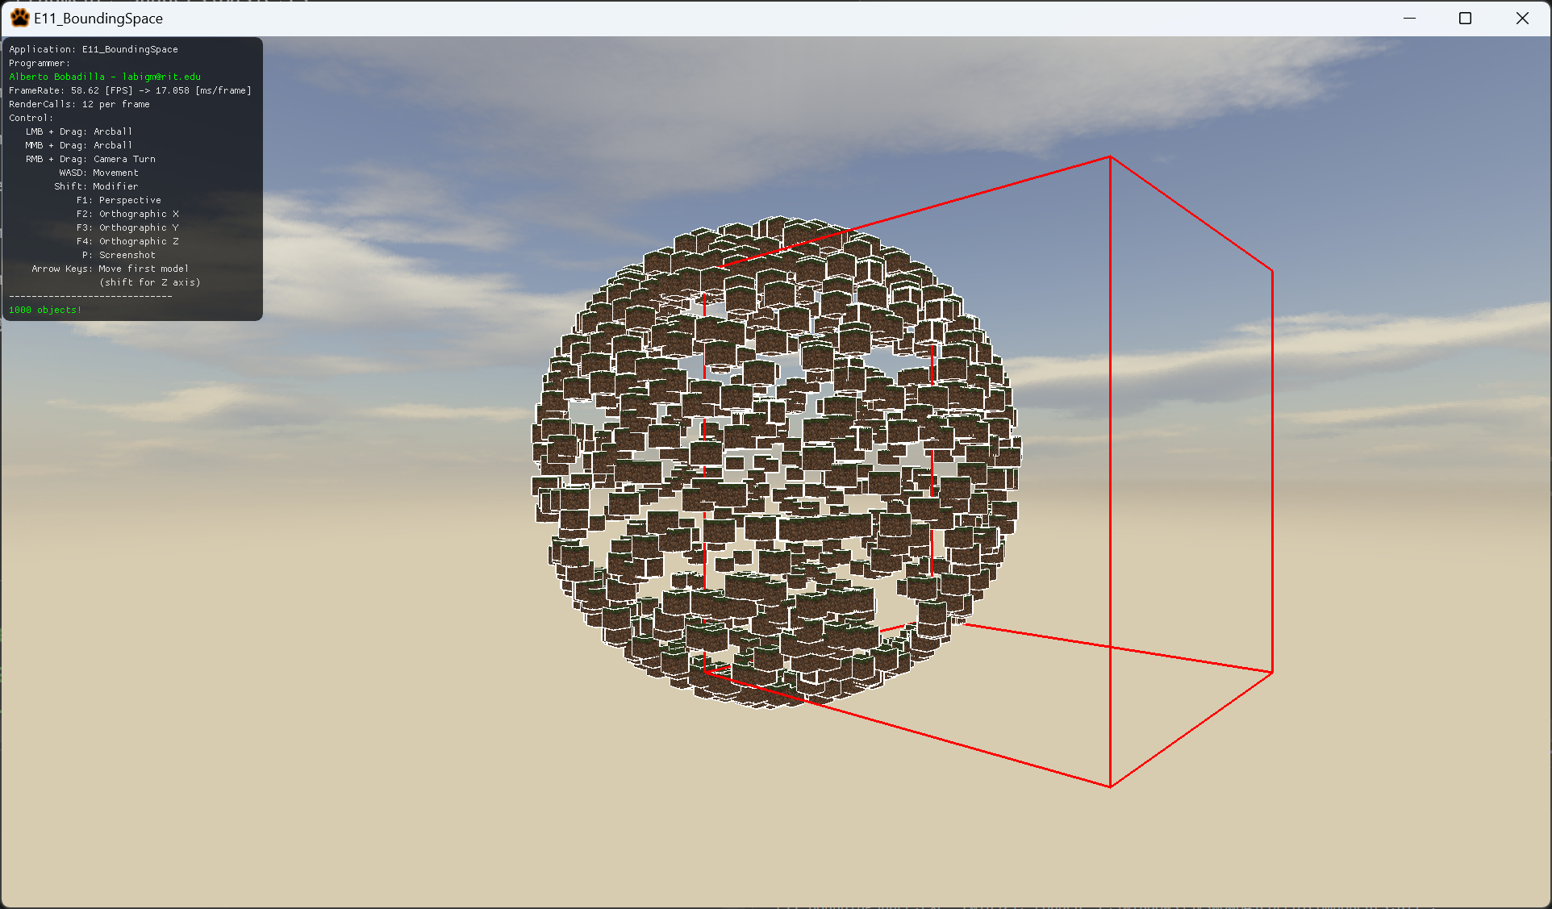

The center is not in the right place neither is the size.

1. For this you will need to initialize the variables taking in account all objects in the world and make a box that surrounds the object exactly.
2. You are only modifying the AppClass.cpp so this is the only file you need to submit

